Challenges - Monday 27th April

Equivalent fractions, decimals and percentages

Part 1
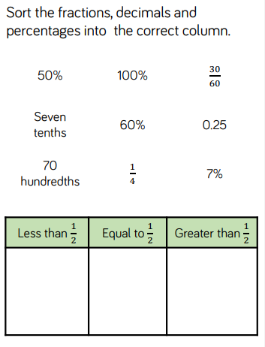

Part 2
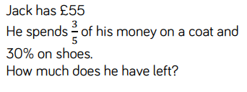

Part 3
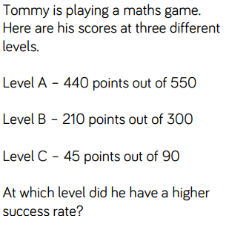
Part 4
In a survey people were asked if they like tea and coffee.
The results are in this Venn diagram.

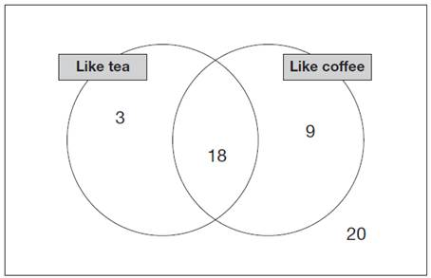
(a) What percentage of people in the survey like both tea and coffee?

(b) What percentage of people in the survey do not like coffee?

