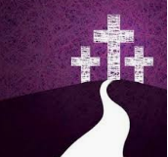
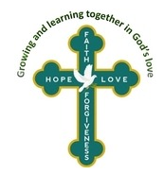
RE at Home
Sacrifice

St Mark’s RE at home
The purpose of these activities is to provide your children with a time of reflection and focus in the period leading up to and beyond Easter. You may want to choose an activity, or just several of them. This is not RE as we would do it at school, but a resource to support your child’s understanding of the Christian celebration of Easter.
You may have a more creative way in which to share the story, please use these, or not as you wish.
Write a few sentences telling someone else about a time when you had to make a sacrifice either yourself or as a family.

What does the word sacrifice actually mean?
Use a dictionary to find out or talk to your family.

How can making a sacrifice make us feel? When you have made a sacrifice, how did it make you feel? Why? Did it have an impact on anyone else? How did it make them feel?
Draw a picture of the sacrifice you made. Add feelings labels for each person involved.
School Values Weekly Bible Reading Challenge
Faith Forgiveness Hope Love
`For God so loved the world that he gave his only Son – that whoever believes in him will have everlasting life`
(John Ch3 v16)
In your opinion, which school value does this Bible verse link to the best and why?

School Values Weekly Bible Reading Challenge
Faith Forgiveness Hope Love
`For God so loved the world that he gave his only Son – that whoever believes in him will have everlasting life`
(John Ch3 v16)
In your opinion, which school value does this Bible verse link to the best and why?

With a grown-up, look online for artists who have painted the sacrifice of Jesus when he was put on the cross to die.
How do you feel when you look at these pictures?

Jesus made a sacrifice of his life when he died on the cross for us.
Draw your own picture showing this special thing that Jesus did.

