Challenges - Monday 4th May

Adding Decimals with the Same Decimal Places

Part 1
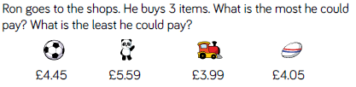

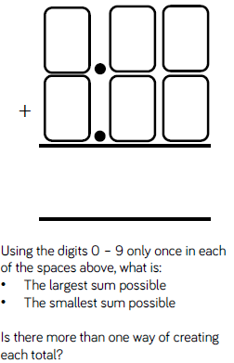
Part 2
Part 3 – SATs Questions
Q1.

Large pizzas cost £8.50 each.
Small pizzas cost £6.75 each.
Five children together buy one large pizza and three small pizzas.
How much does it cost?

2 marks
Q2.

A shop sells pairs of socks.
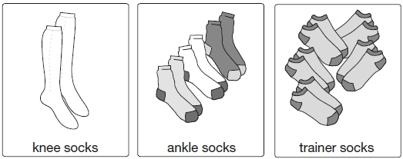
1 pair for £5.45 3 pairs for £7.50 5 pairs for £8. 50

Kirsty buys 1 pair of knee socks and 3 pairs of ankle socks.
She pays with a £20 note.
How much change does she get?

2 Marks

