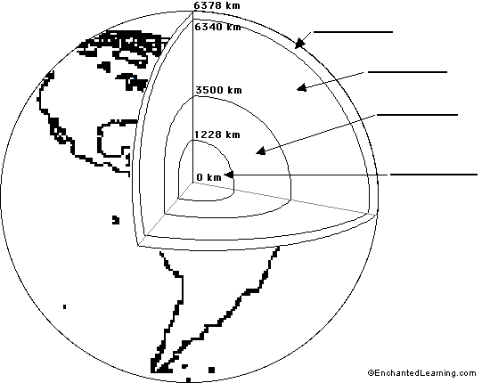

Name of Earth’s layer | How thick is it? | Description
Crust | 5-20 miles
Mantle | 1800 miles
Outer core | 1400 miles
Inner core | 800 miles

