Tuesday 5th May. 2020
Varmints predictions
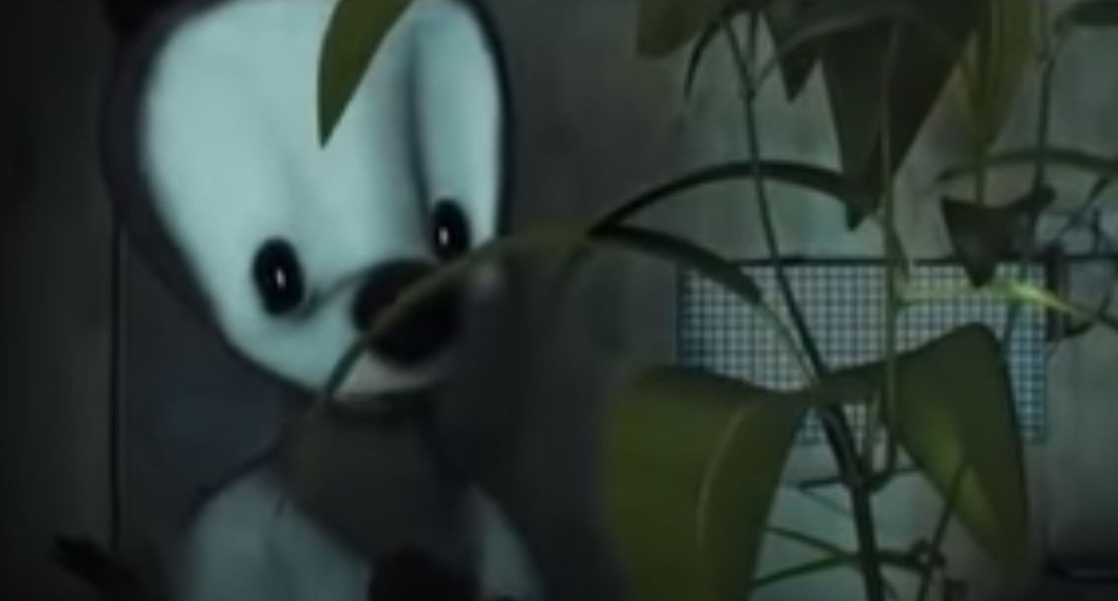

What do you think he will do with his little piece of wilderness?
____________________________________________________________________________________________________________________________________________

Why do you think he's left his important things behind?
____________________________________________________________________________________________________________________________________________

Where do you think the 'safe place' is?
____________________________________________________________________________________________________________________________________________

