Challenges - Tuesday 5th May

Subtracting Decimals with the Same Decimal Places

Part 1

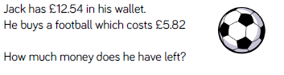

Part 2

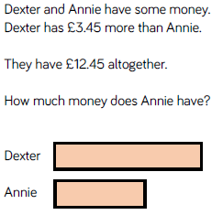

Part 3

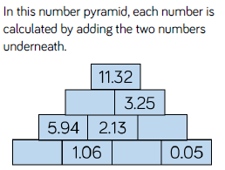

Part 4 – SATs Questions

**Q1.**

Jacob cuts **4** metres of ribbon into **three** pieces.

The length of the first piece is **1.28** metres.

The length of the second piece is **1.65** metres.

Work out the length of the third piece.

2 marks

**Q2.**

A shop sells three types of sunglasses.

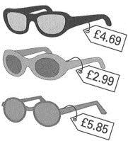

What is the **difference** in price between the **most** expensive and **least** expensive sunglasses?



1 mark

The shop also sells sun hats.

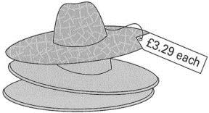

Ryan buys the **£4.69 sunglasses** and a **sun hat**.

How much change does he get from **£10**?