Challenges - Wednesday 6th May

Adding Decimals with Different Decimal Places

Part 1

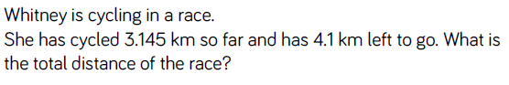

Part 2
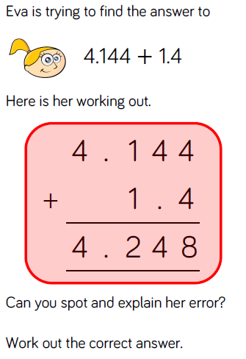

Part 3
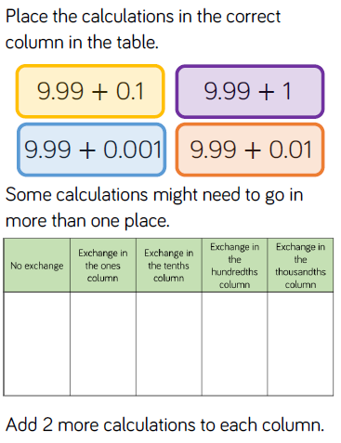
Part 4 – SATs Questions
Q1.

Calculate 52.85 + 143.6

Q2.

Tick (✔) the two numbers which have a total of 10

