[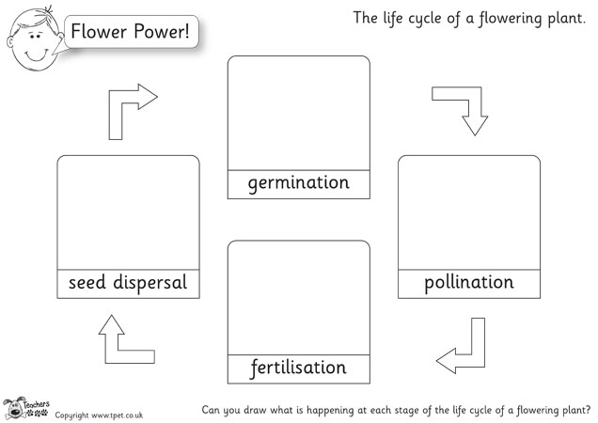](http://www.google.co.uk/url?sa=i&rct=j&q=&esrc=s&source=images&cd=&cad=rja&uact=8&ved=0ahUKEwiStpGYwZ3MAhXDVxoKHZU8AL8QjRwIBw&url=http://activities.tpet.co.uk/?resource=151&psig=AFQjCNGmR4uAr7hh2EeNauhba0GGa_Jzkw&ust=1461251515736450)