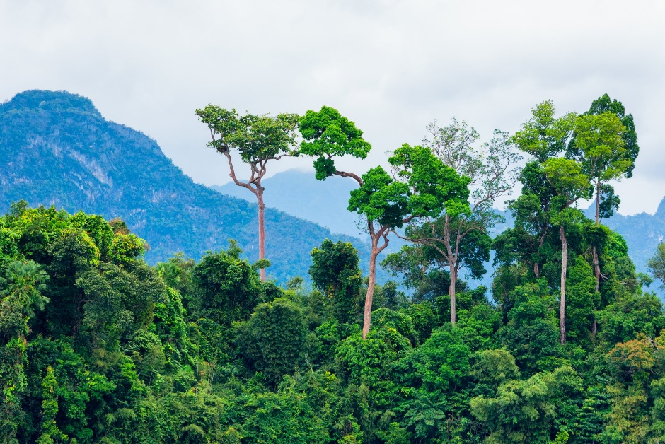

For **Computing**, the children will discover the history of Bletchley Park and learn about code breaking and password hacking. They will have the opportunity to demonstrate some of their digital literacy skills by creating presentations about historical figures.

In **Music,** the children will be exploring and identifying the characteristics of film music. They will use graphic scores to interpret different emotions in film soundtracks. Finally they will be creating their own composition and graphic score to perform alongside a film.

music

In **Art,** we will look at the work of Georgia O’Keefe, who used a close-up approach to paint abstract style pictures of nature. After replicating some of her work with a range of media to analyse which works best, the children will be creating their own artwork of Amazon flora and fauna. The children will then create landscapes of Brazil, showing different elements of their culture using bright, bold colours.

**PE** will take place every Wednesday. Due to not being able to change clothes in school, all children will need to come into school on this day wearing their full PE kit. We recommend bringing a PE jumper or hoodie, as well as their coat, for chilly and wet days!

In **Science**, the children will learn about the life processes of all living organisms. They will then explore how living things (including animals and plants) are classified into broad groups according to their common characteristics. We will think about why it is so important to be able to classify plants and animals based on specific characteristics. Linking to our jungle-based topic, we will delve into the reasons why some creatures are deadly.

With a greater emphasis on quality texts within our **English,** we begin by exploring The Great Kapok Tree by Lynne Cherry. Using this emotive story, which highlights the issues of deforestation, we will write a diary entry in role as one of the animals, whose home is within the Kapok Tree. Children will look at the harmful effects of deforestation and this will be followed by studying a speech given by Greta Thunberg. We will look at both sides of an argument which will allow children to develop a balanced approach in order to debate the future of the rainforests.

In **Maths** this half-term, we will initially focus on place value to secure our understanding of number. The children will use lots of pictorial diagrams to compare and order numbers up to ten million. Within this unit, the children will also cover rounding to the nearest appropriate boundary as well as exploring negative numbers. When our place value knowledge is secure, we will move on to deepening our learning of the four operations (+ - x ÷).

**Olá Brazil!**

**Key Concepts: Responsibility and Respect**

**Geography** will be the main focus for this half-term studying the diverse and unique culture of Brazil. Throughout the unit, we will compare the geography of Brazil to that of the UK (an integral element of the new primary curriculum). We will begin by studying the human and physical features of Brazil before placing Brazil in the wider context of South America and the world. We will investigate the many differences between urban and rural Brazil and case study the lives of people living within Rio de Janeiro.

Our **RE** unit will help us to explore pilgrimage, with the key question: Why do people of faith go on pilgrimages? We begin by thinking about special journeys that we have made. This helps us to consider how important pilgrimage is, within the religion of Islam, to Muslim people. We will explore their rituals of Hajj - a very important journey for Muslims.