Geographical Vocabulary
rainforest | A dense forest, normally found in tropical areas with high rainfall. They generate much of the world’s oxygen.
country | A nation with its own government e.g. UK, USA, Germany
continent | The world’s main continuous pieces of land – Africa, Asia, Australasia, Europe, North America, South America, Antarctica
equator | Imaginary line through the middle of the Earth that receives the most sunlight.
Tropic of Cancer/Capricorn | Imaginary lines north and south of the equator. Most rainforests can be found between these two lines.
climate | The weather and temperature usually found in an area over a long period of time.
biome | A large region of Earth that has a certain climate and certain types of living things.
temperate | Places where it is neither very hot nor very cold. Usually has warm summers and cool winters.
tropical | Around the middle of the world in the region called the Tropics where it is warm all year.
biodiversity | The wide range of living things on Earth.
ecosystem | A community of plants and animals that rely on each other to survive.
indigenous | A living thing that belongs naturally to an area.
deforestation | The action of clearing a wide area of trees.
human features | Areas of land which are man-made/synthetic. They are there because of human ideas and actions.
physical features | These are the physical characteristics of the land and are there naturally (mountains, rivers etc.)
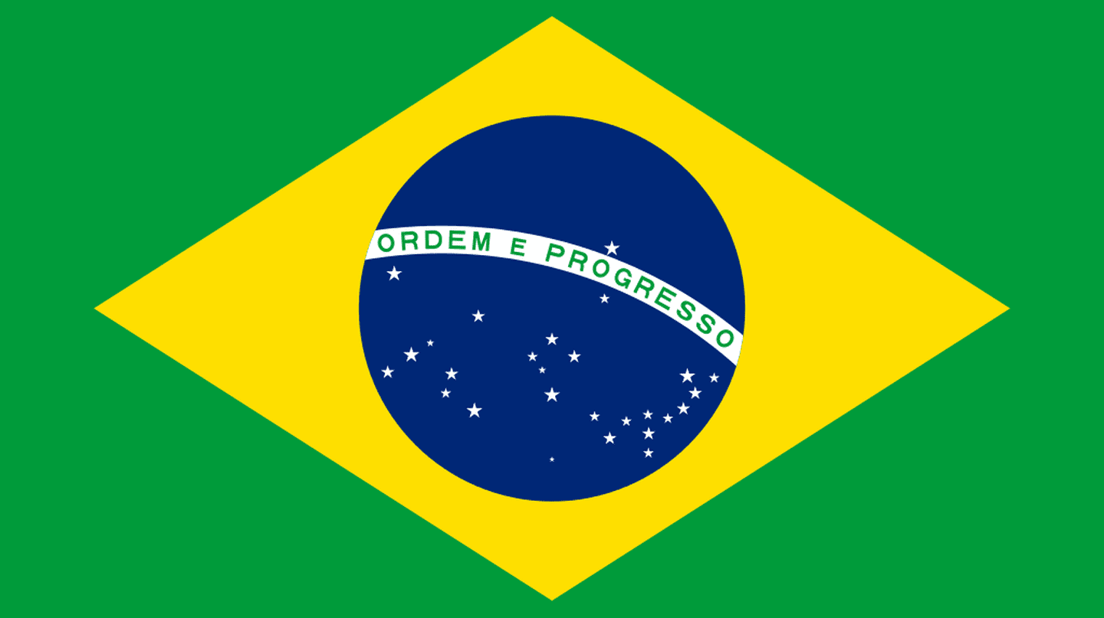
Key Concept: Responsibility and Respect
Olά Brazil!
Knowledge Organiser
Layers and Features of the Rainforest
Emergent Layer | Giant trees that enjoy the most sun but high winds and cold.
Canopy | Dense layer of trees overlapping each other. Home to most animals in rainforests.
Understory | Relatively dark, open area below the canopy.
Undergrowth | Also known as the forest floor, mainly consisting of fallen leaves, fruit etc. that decomposes as food for trees.
Flora & Fauna | Flora = plants; Fauna = animals
Camouflage | Blending in to hide in the natural environment.

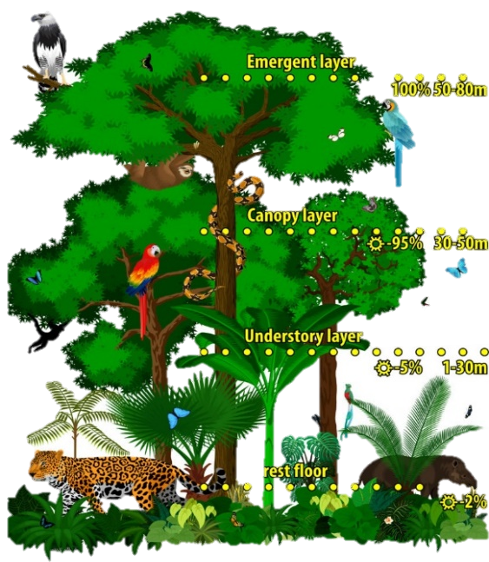

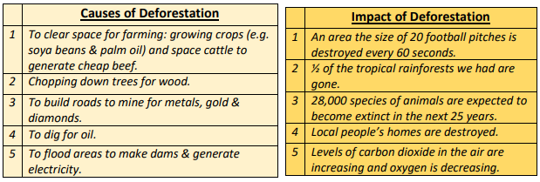

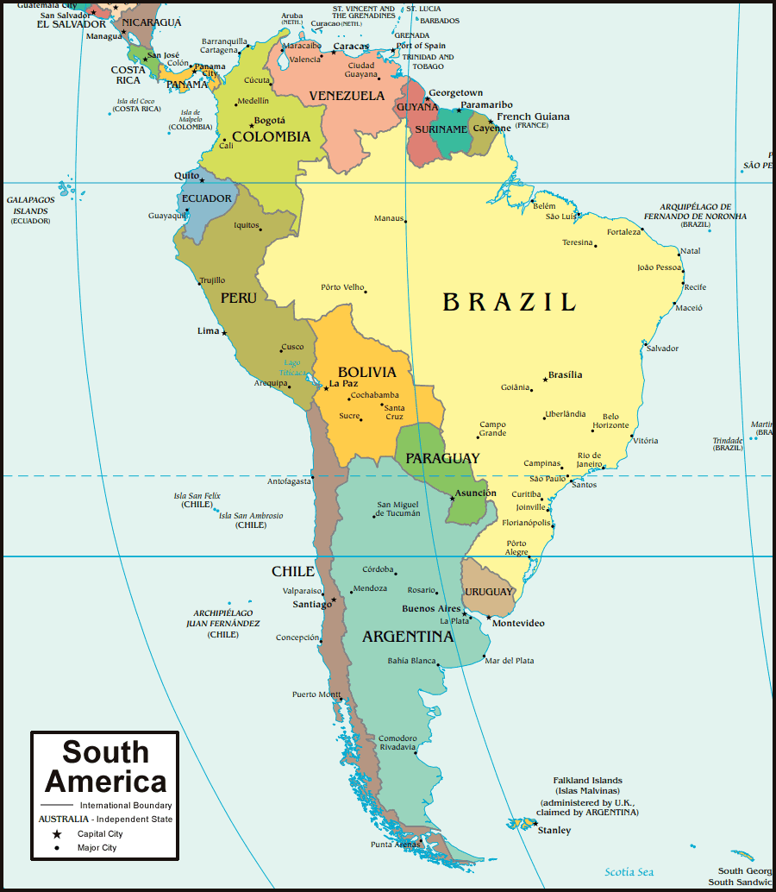

Key Information about Brazil
Continent | South America | Capital city | Brasilia
Surrounding waters | Atlantic ocean  Amazon river | Main language | Portuguese
Religions followed in Brazil | Christianity, Judaism and Islam. | Population | 209.3 million people (2017)
 |  | Other major cities | Sao Paolo, Rio de Janeiro, Porto Alegre, Manaus
Currency | Brazilian real (BRL) | Famous for… | The Amazon jungle, Carnival and 2016 Olympics

