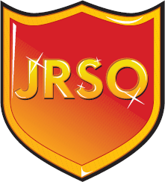
St. Mark’s JRSO
Elections 2022
Year 4
Elections for St. Mark’s JRSO (Junior Road Safety Officer) will be held on Friday 14th October. This is run by Mrs Brackenridge and Mrs Barr. If you would like your name to be put forward then please complete the box below writing the qualities that you have to be a good Junior Road Safety Officer.

These forms must be handed to your teacher by Friday 7th October. Sorry, but late entries will not be accepted.

Good luck!

Name: _______________________________________________________

Class: ________________

