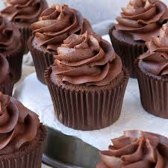
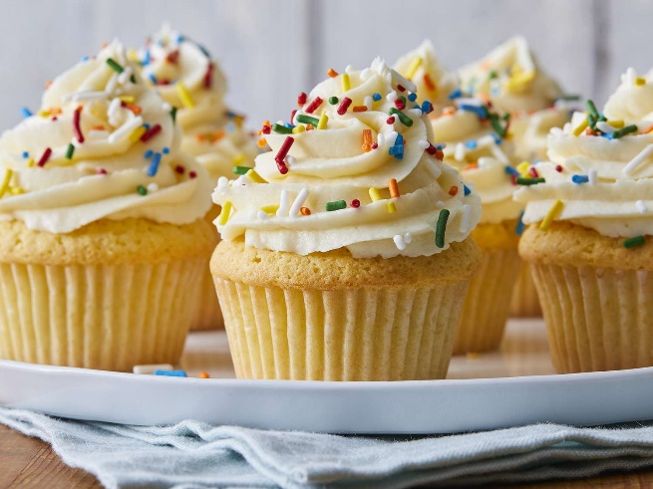

The Great Year 6 Cake Giveaway
On Wednesday, 7th February, Year 6 will spread kindness and cheer with their great big cake giveaway. We are hoping that, as agents of change, the children will bring in approximately six cupcakes or cookies each to share with children in all year groups. It is sure to put a huge smile on everyone’s face. Cakes and cookies can be home-baked (a great way to reinforce measures with your children) or shop bought.
We kindly ask for all children to bring in their cakes on Wednesday morning so we can distribute them in time for our morning break.
As always, cakes and cookies must be nut-free.
Thank you so very much for all your support to promote our wellbeing week at school.

